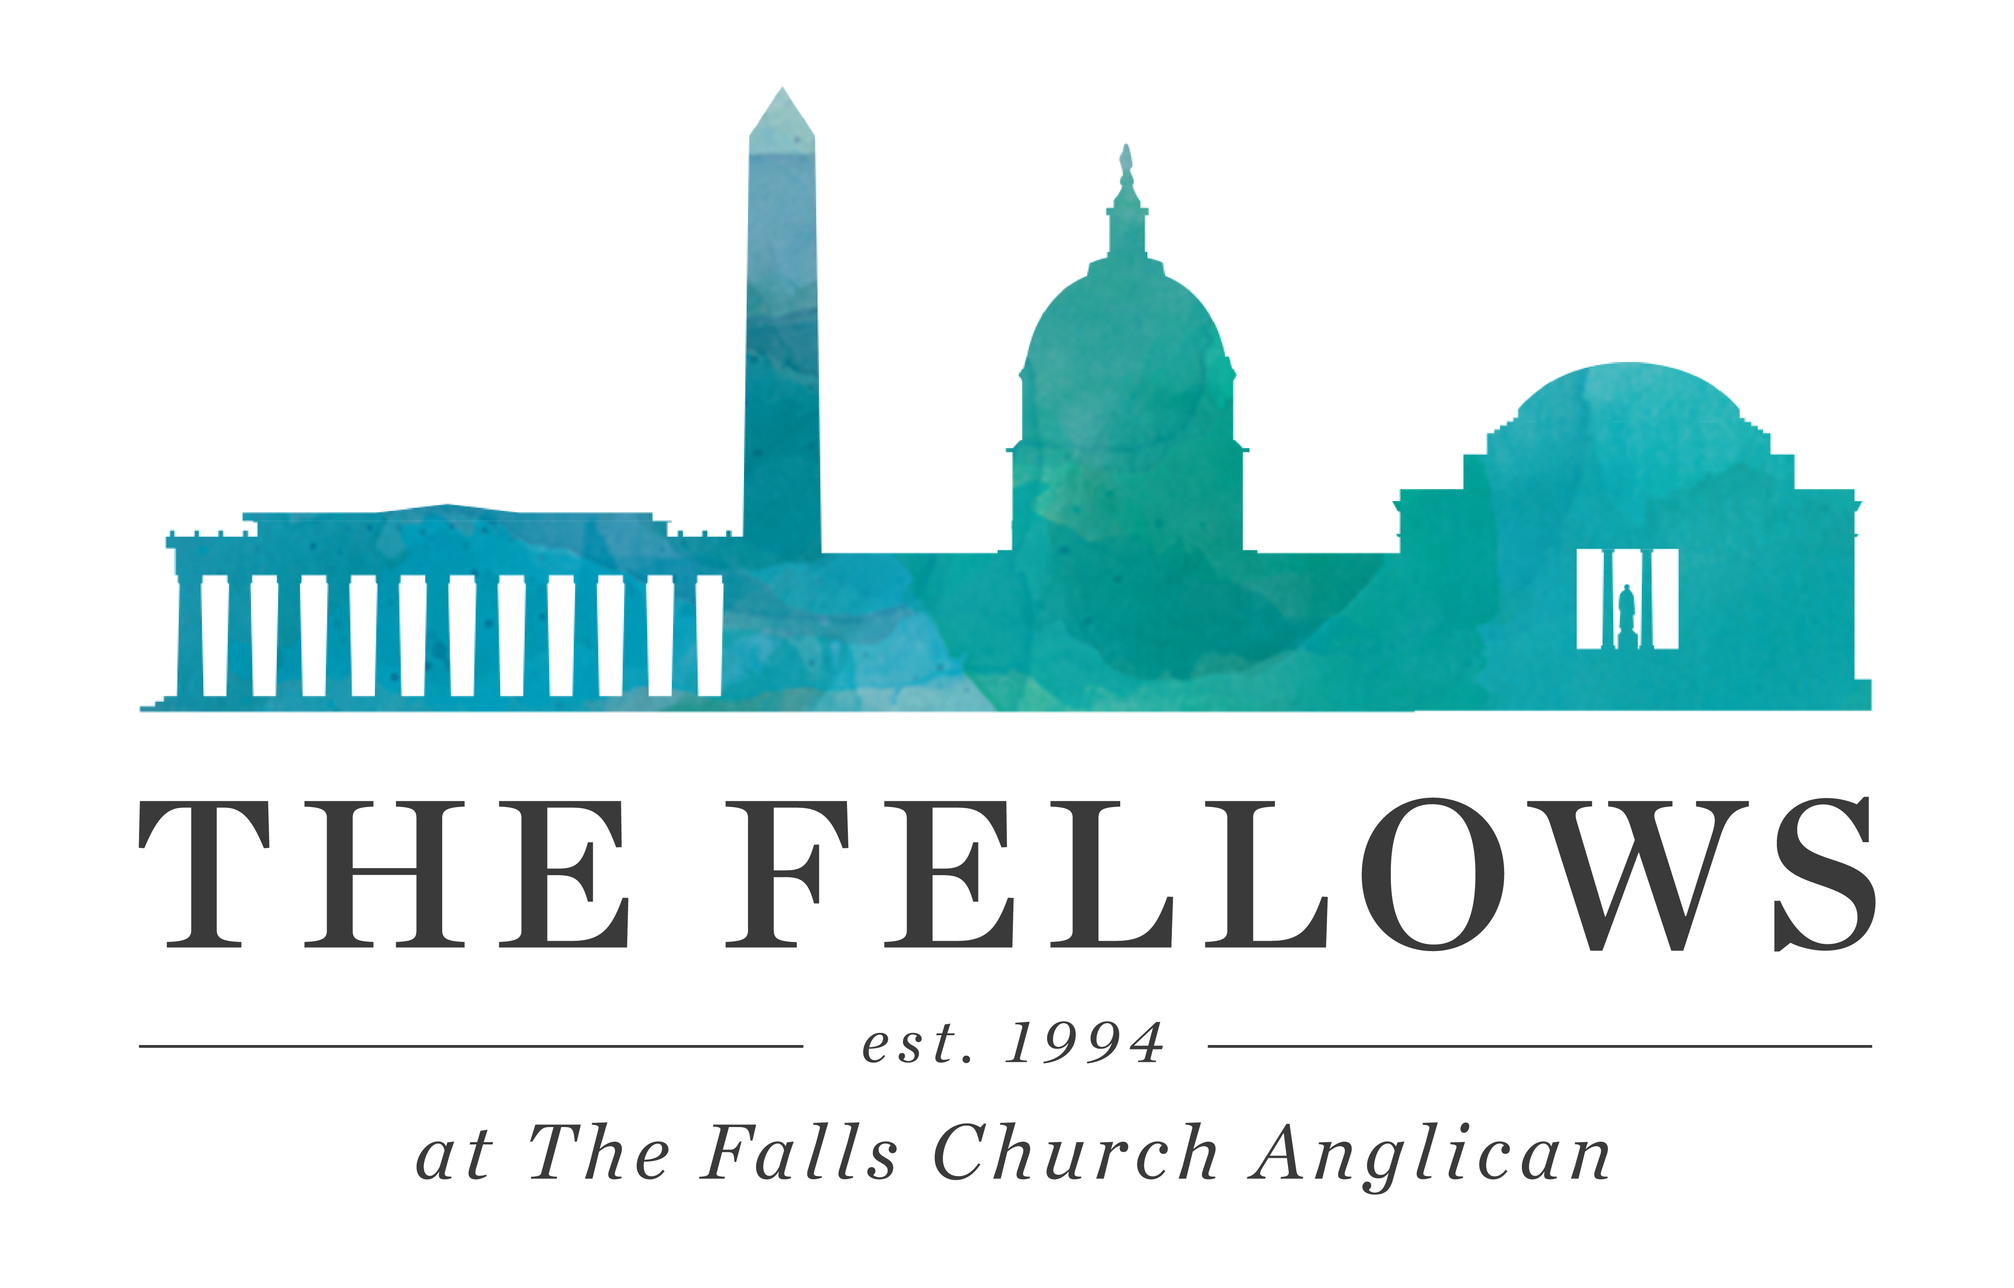
APPLICATION FOR ADMISSION
The Falls Church Fellows
6565 Arlington Blvd.-Suite 300, Falls Church, VA 22042
www.fallschurchfellows.com  www.tfcanglican.org
⬥
Thank you for your interest in The Fellows Program at The Falls Church Anglican. As the founding Fellows program, we have 27 years of rich history in filling classes with young adults eager to enter into Christian community where faith is applied in vocation, discipleship, academics, fellowship, and family. Above all, we desire to love and exalt Jesus Christ with both heart and mind.

Email completed form to fellows@tfcanglican.org

A. PERSONAL INFORMATION
Name
Gender
Email
Cell Phone
Current Address
DrLicense#/State
Birthdate | _ _/_ _/_ _
Parent Names
Parent Address
Parent Phone
Denomination and home church
University
Major
GPA
Year Entered |  | Expected Grad. Date
Other Universities/Dates

Work Placement Field Preference (indicate with an X, up to 3)

 | Student Ministry Staff |  | Government |  | Public Relations/Communic.
 | Education |  | Arts |  | Other:
 | Non-profit/ministry |  | Business |  | Other:

“I affirm that the information I have provided on this application and all attachments is true and correct. By signing below, I also authorize The Falls Church Anglican Fellows Program to make independent inquiries about me.”

Signature/Date:

B. SHORT ANSWER
This part of the application is our chance to get to know more about you.
Please tell us in a paragraph:
1) How you learned about The Falls Church Fellows Program and what attracts you to it.
2) Your spiritual background and testimony. Please include your statement of belief regarding salvation and your current relationship to God.
3) Your thoughts on sharing your faith. Please include an example.
4) What career field you feel God leading you to and why.
5) Your relationship with your parent(s) and any siblings.
6) Describe someone who has influenced your life in an important way.
7) What you perceive are your greatest strengths and weaknesses. Include your personality, values and work ethic.
8) Your experience working with teenagers or in student ministry and how your gifts will contribute as a student ministry small group leader. What are your concerns about being a small group leader?
9) Your position on each of the following issues: alcoholic beverages, drugs, premarital sex, smoking, homosexuality, and abortion.
10) Are you in counseling, under a medical doctor’s care, or on medication for emotional/psychological/physical reasons? Please explain.
11) Have you ever been convicted of anything more serious than a traffic violation? If yes, please explain.
12) Have you applied to any other Fellows programs? We try to coordinate admissions efforts with other programs – please rank the programs according to your preference.

[Section C on following page!]

C. PLEASE ALSO PROVIDE:
1. A one-page professional resume listing work and volunteer experiences since graduating from high school, and any college honors or awards. This will be used in arranging your work-place internship.
2. A current photo.
3. Names and e-mail contact information for at least three references (ex: John Smith, jsmith@xyz.com, pastor).
- pastoral/spiritual reference
- employer reference
- character
4. Please sign here (electronic is suitable) that you have read the Doctrinal Foundations held by The Falls Church Anglican (http://www.tfcanglican.org/visit/what-we-believe/), and that you are able to operate within this framework during your time as a Fellow.
Signed__________________________________________ Date ____________
Please note that prior to arriving, Fellows must provide proof of a full physical examination within one year of the start date. We will also ask for your doctor’s contact info, so we can provide continuity in an emergency.

Please email the completed application to: fellows@tfcanglican.org

You will receive confirmation of receipt within 2-3 days.
Thank you – we look forward to talking with you!

